Enterprise Networking | Small Office Home Office

XYZ company is a fast-growing company in Eastern Australia with more than 2 million customers globally. The company deals with selling and buying of food items, which are basically operated from the headquarters. The company is intending to open a branch near the local village Bonalbo. Thus, the company requires young IT graduates to design the network for the branch. The network is intended to operate separately from the HQ network.

Being a small network, the company has the following requirements during implementation.
- One router and one switch to be used
- 3 departments (Admin/IT, Finance/HR and Customer Service/Reception)
- Each department is required to be in different VLANS
- Each department is required to have wireless network for the users
- Host devices in the network are required to obtain IPv4 address automatically
- Devices in all the departments are required to communicate with each other

Assume the ISP gave out a base network 192.168.1.0, you as the young network engineer who has been hired, design and implement a network considering the above requirements.

Topology
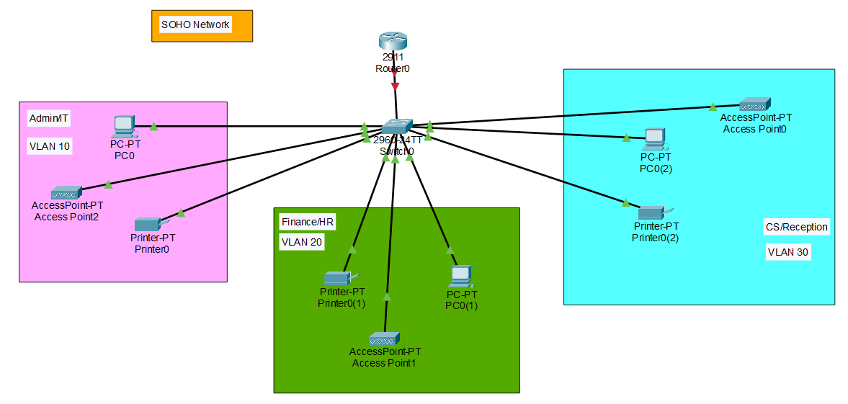
Subnetting
Base Network: 192.168.1.0
No. of subnets = 3
Formula : No. of subnets = 2^n (n represents number of borrows bits)
2^n=3 ===== n=2
Class C = 255.255.255.0 === Binary 11111111. 11111111. 11111111.00000000
Borrow 2 bits ==== 11111111. 11111111. 11111111.11000000 == 255.255.255.192
1st Subnet  Net ID: 192.168.1.0  Broadcast ID: 192.168.1.63  Host Range: 192.168.1.1-192.168.1.62 | 3rd Subnet  Net ID: 192.168.1.128  Broadcast ID: 192.168.191  Host Range: 192.168.1.129-192.168.1.190
2nd Subnet  Net ID: 192.168.1.64  Broadcast ID: 192.168.1.127  Host Range: 192.168.1.65 – 192.168.1.126 | 4th Subnet  Net ID:192.168.1.192  Broadcast ID: 192.168.1.255  Host Range: 192.168.1.193- 192.168.1.254
IP Addresses:

R1
------------------------------------Bring interface UP
Router(config)#hostname R1
R1(config)#int g0/0
R1(config-if)#no sh
------------------------------------Inter-vlan Routing
Admin/IT
R1(config-if)#int g0/0.10
R1(config-subif)#encapsulation dot1Q 10
R1(config-subif)#ip address 192.168.1.1 255.255.255.192

Finance/HR
R1(config-if)#int g0/0.20
R1(config-subif)#encapsulation dot1Q 20
R1(config-subif)#ip address 192.168.1.65 255.255.255.192

CS/Reception
R1(config-if)#int g0/0.10
R1(config-subif)#encapsulation dot1Q 30
R1(config-subif)#ip address 192.168.1.129 255.255.255.192

------------------------------------Config DHCP
R1(config)#service dhcp
------------------------------------Config DHCP Pools, gateways, dns & domain
R1(config)#ip dhcp pool Admin-Pool
R1(dhcp-config)#network 192.168.1.0 255.255.255.192
R1(dhcp-config)#default-router 192.168.1.1
R1(dhcp-config)#dns-server 192.168.1.1
R1(dhcp-config)#domain-name Admin.com

R1(config)#ip dhcp pool Finance-Pool
R1(dhcp-config)#network 192.168.1.64 255.255.255.192
R1(dhcp-config)#default-router 192.168.1.65
R1(dhcp-config)#dns-server 192.168.1.65
R1(dhcp-config)#domain-name Finance.com

R1(config)#ip dhcp pool CS-Pool
R1(dhcp-config)#network 192.168.1.28 255.255.255.192
R1(dhcp-config)#network 192.1 68.1.128 255.255.255.192
R1(dhcp-config)#default-router 192.168.1.129
R1(dhcp-config)#dns-server 192.168.1.129
R1(dhcp-config)#domain-name CS.com

Sw1
------------------------------------VLAN
SW1(config)#vlan 10
SW1(config-vlan)#name Admin/IT
SW1(config-vlan)#vlan 20
SW1(config-vlan)#name Finance/HR
SW1(config-vlan)#vlan 30
SW1(config-vlan)#name CS/Reception

------------------------------------Port Access to vlans per department
Admin/IT
SW1(config)#int ran f0/2-4
SW1(config-if-range)#switchport mode access
SW1(config-if-range)#switchport access vlan 10

Finance/HR
SW1(config)#int rang f0/5-7
SW1(config-if-range)#switchport mode access
SW1(config-if-range)#switchport access vlan 20

CS/Reception
SW1(config)#int ran fa0/8-10
SW1(config-if-range)#switchport mode access
SW1(config-if-range)#switchport access vlan 30

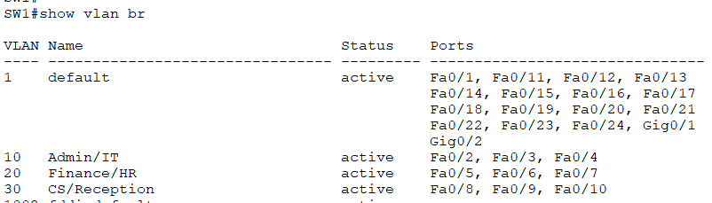

------------------------------------Trunking
SW1(config)#int fa0/1
SW1(config-if)#switchport mode trunk

Admin/IT VLAN 10
AP: Admin-WiFi | Admin@123

Finance/HR VLAN 20
AP: Finance-WiFi | Finance@123

CS/Reception VLAN 30
AP: CS-WiFi | Customer@123

